AS statement or Alias Statement : Using AS to change the name of amount to num trans

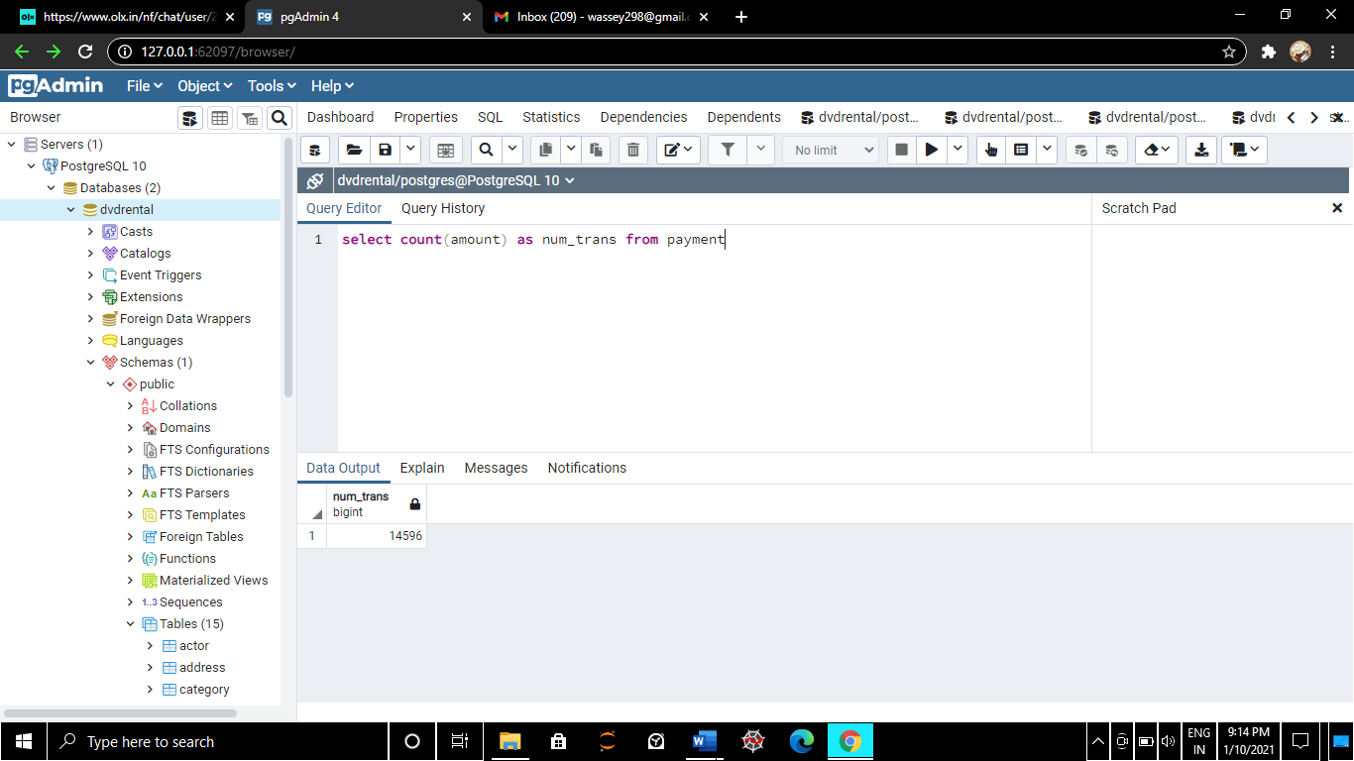

Changing amt to total spent

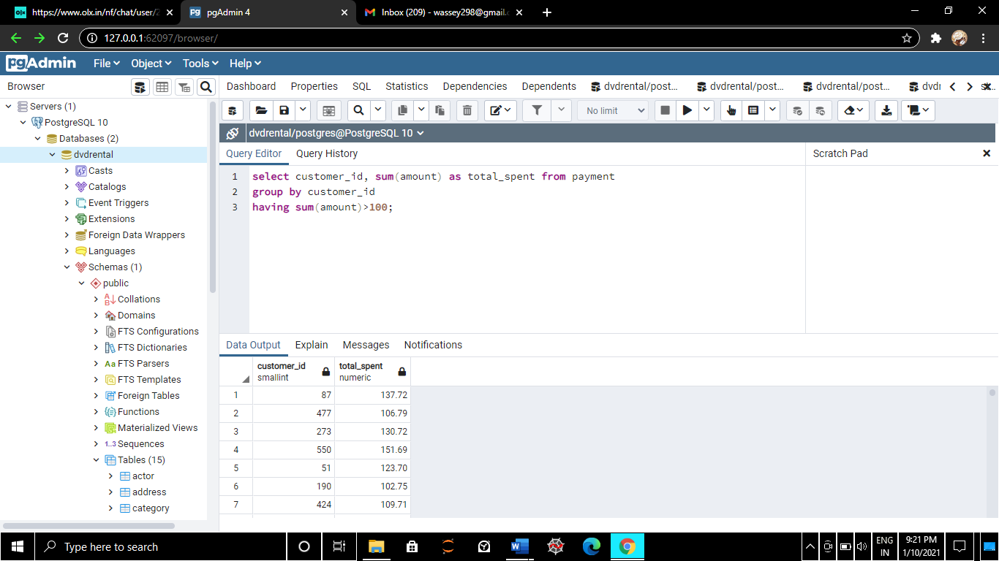

INNER JOINS or Joins: here we are joining two tables taking their common column

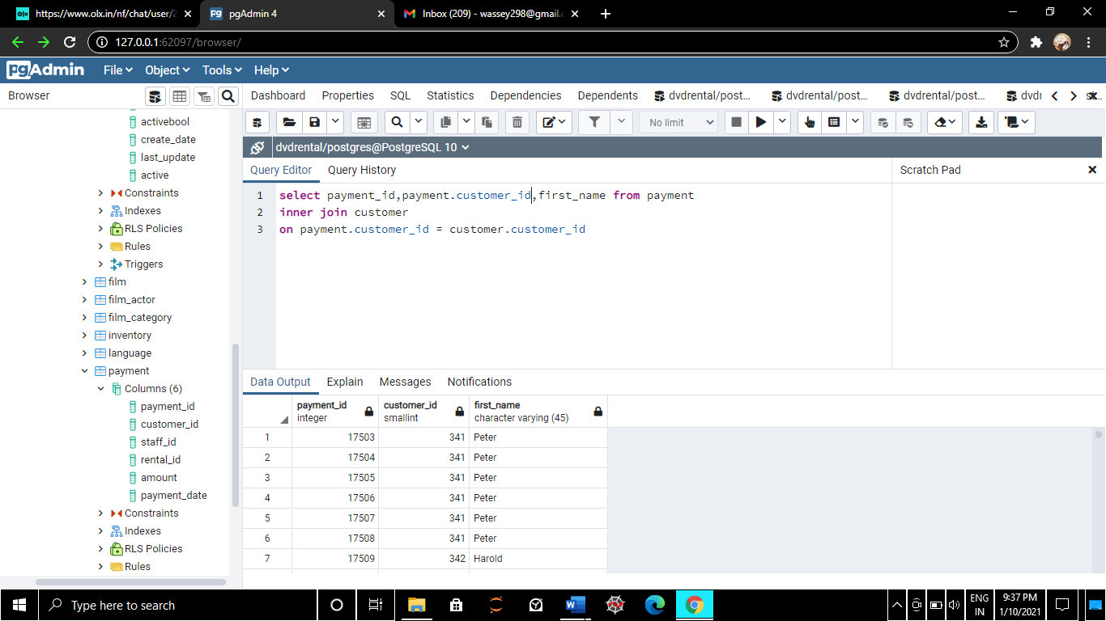

Customers who doesn’t have any information or any unique rows

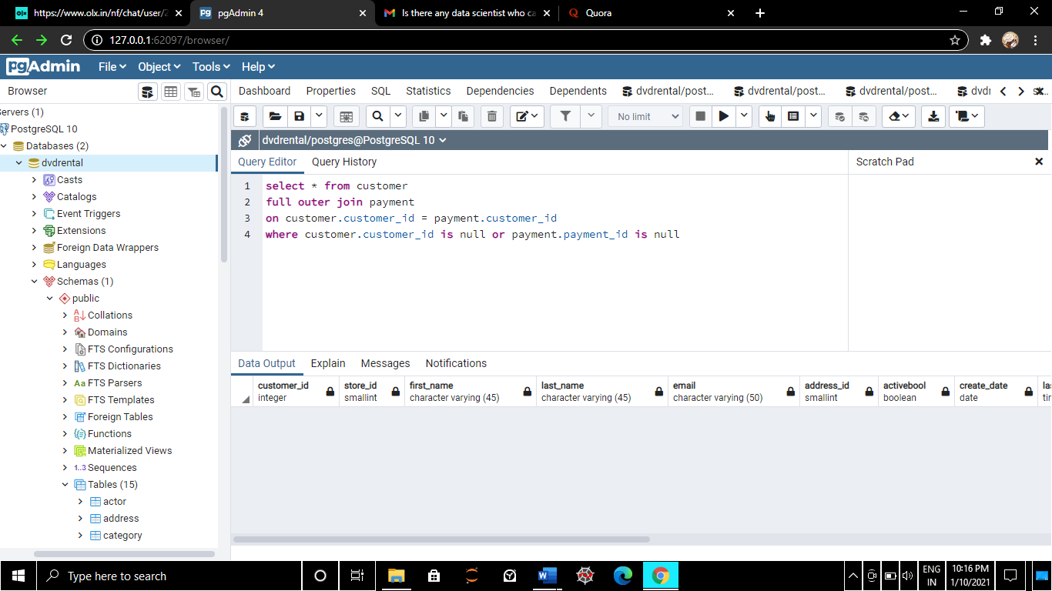

Left Join: Here we are left joining film on inventory table.

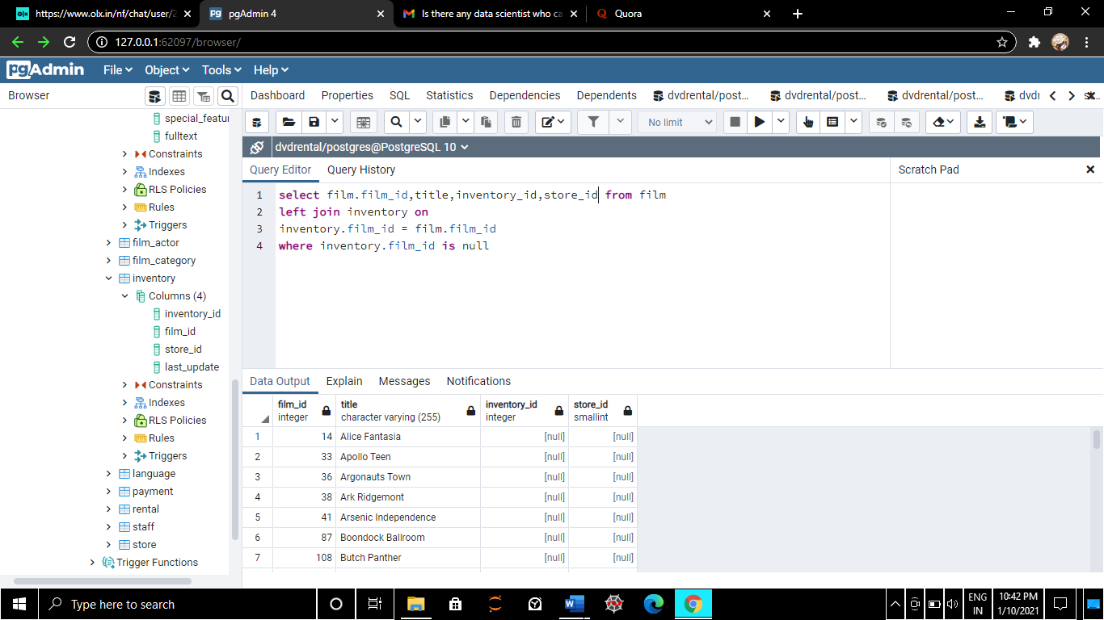

What are the emails of the Customers who live in California using inner join

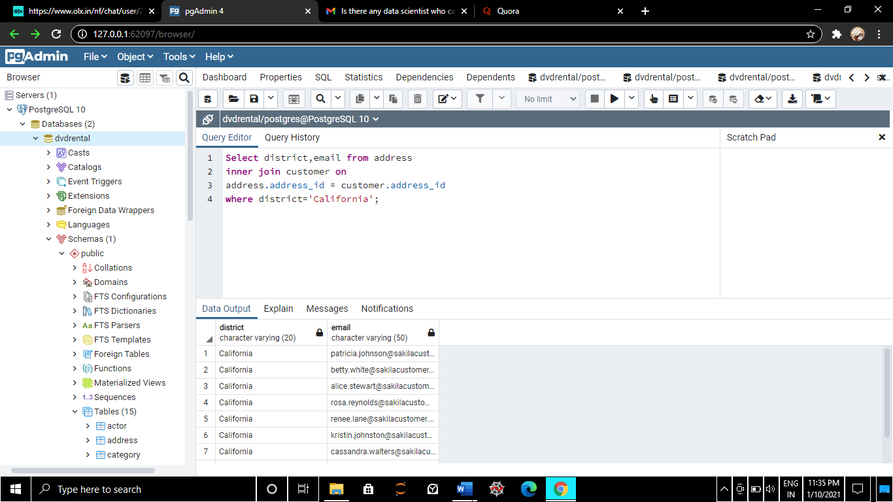

A customer walks in and want to know in which movie nick Wahlberg is in, here we need to do 2 table joins

